**BUISENESS PROBLEM**

In recent years, city hotels and resort hotels have seen high cancellation rates. Each hotel is now dealing with a number of issues as a result, including fewer revenues and less than ideal hotel room use. Consequently, lowering cancellation rates is both hotels’ primary goal in order to increase their efficiency in generating revenue, and for us to offer thorough business advice to address this problem.

The analysis of hotel booking cancellations as well as other factors that have no bearing on their business and yearly revenue generation are the main topics of this report.

**Assumptions**

1. No unusual occurrences between 2015 and 2017 will have a substantial impact on the data used.

2. The information is still current and can be used to analyze a hotel’s possible plans in an efficient manner.

3. The hotels are not currently using any of these suggested solutions.

4. The biggest factor affecting the effectiveness of earning income is booking cancellation.

5. Cancellations result in vacant rooms for the booked length of time.

6. Clients make hotel reservation the same year they make cancellation.

**Research Question**

1. What are the variables that affect hotel reservation cancellations?

2. How to prevent or decrease hotel reservation cancellation?

3. How will hotels be assisted in making pricing and promotional decisions?

**Hypothesis**

1. More cancellation occur when prices are higher.

2. When there is a longer waiting list, customers tend to cancel more frequently.

3. The majority of clients are coming from offline travel agents to make their reservations.

**Analysis and findings**

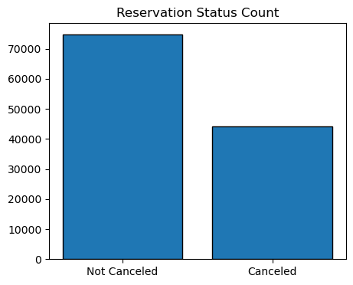

The bar graph shows the percentage of canceled and not canceled reservation. It is obvious that there are a significant number of reservations that have not been canceled. But still 37 % of clients who canceled their reservations, which has a significant impact on the hotels earning.

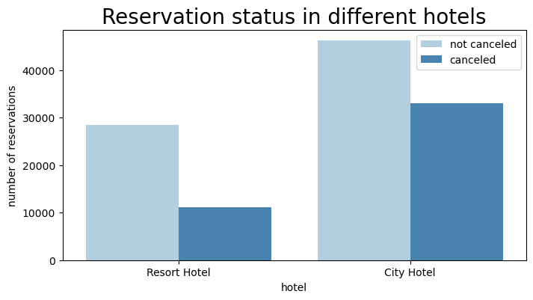

In comparison to resort hotels, city hotels have more bookings. It’s possible that resort hotels are more expensive than city hotels.

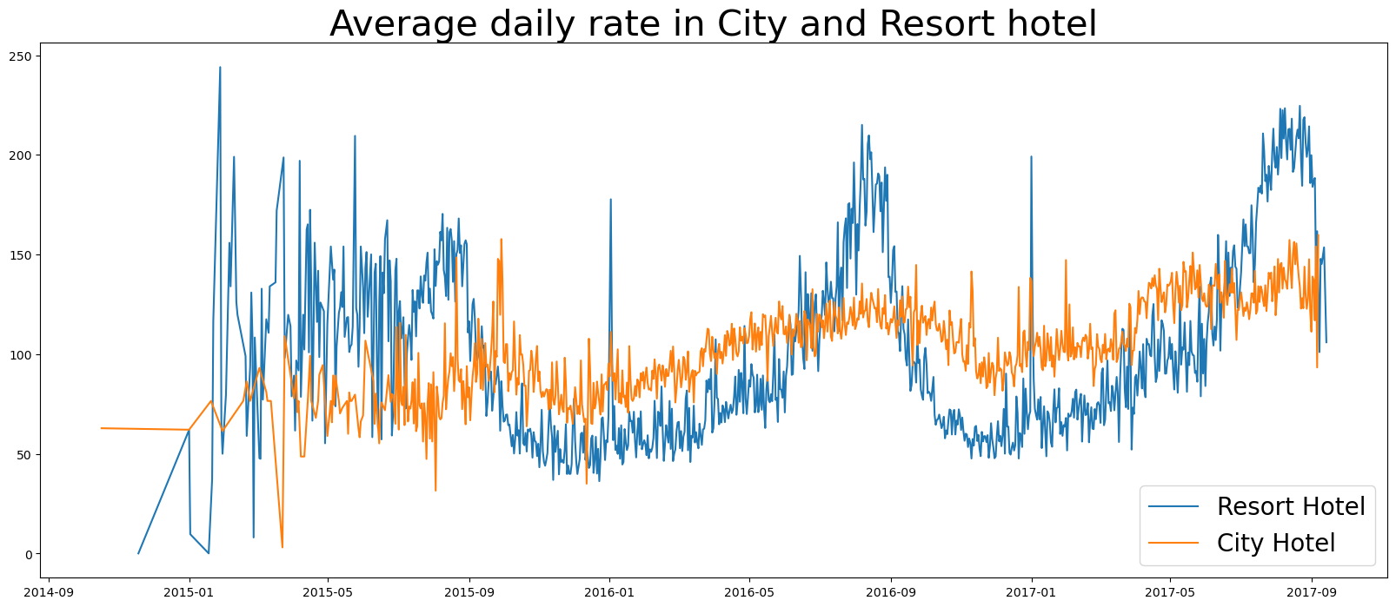

The line graph above shows that, on certain days, the average daily rate for a city hotel is less than that of resort hotel, and on other days, it is even less. It goes without saying that weekends and holidays may see a rise in resort hotel rates.

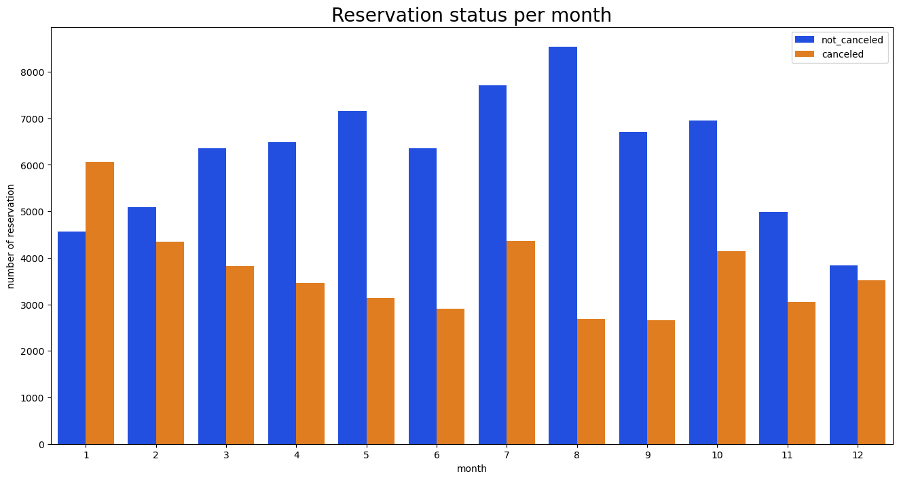

We have developed the grouped bar graph to the month with the highest and the lowest reservation levels according to reservation status. As can be seen, the number of not canceled and canceled reservations are largest in the month of September and January respectively.

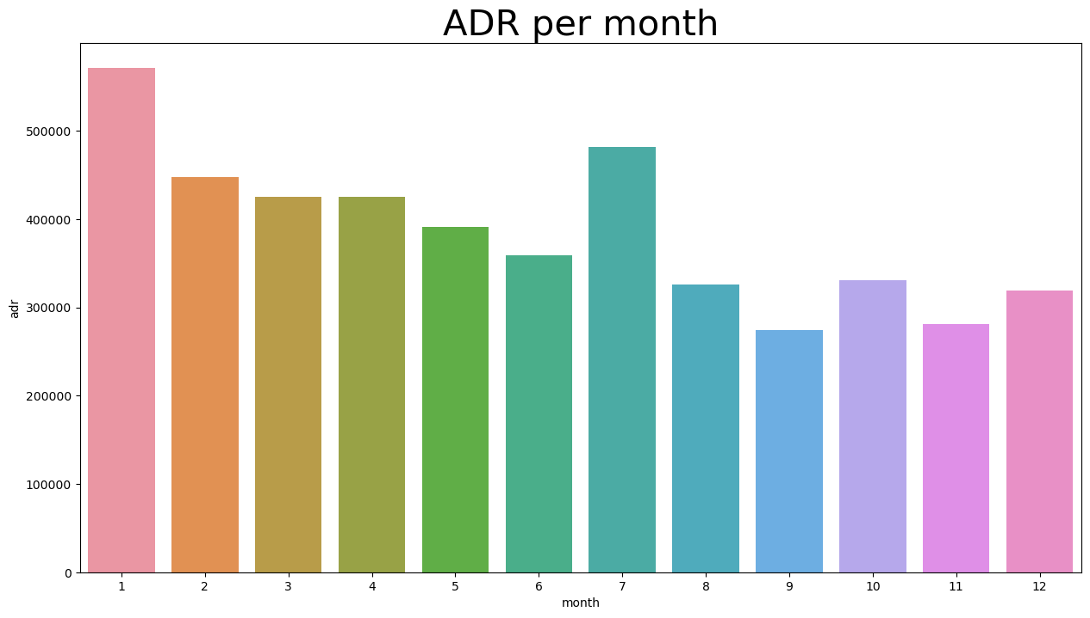

This bar graph demonstrates that cancellations are most common when prices are larger and less common when they are lower. Therefore, the cost of accommodation is mainly responsible for the cancellation.

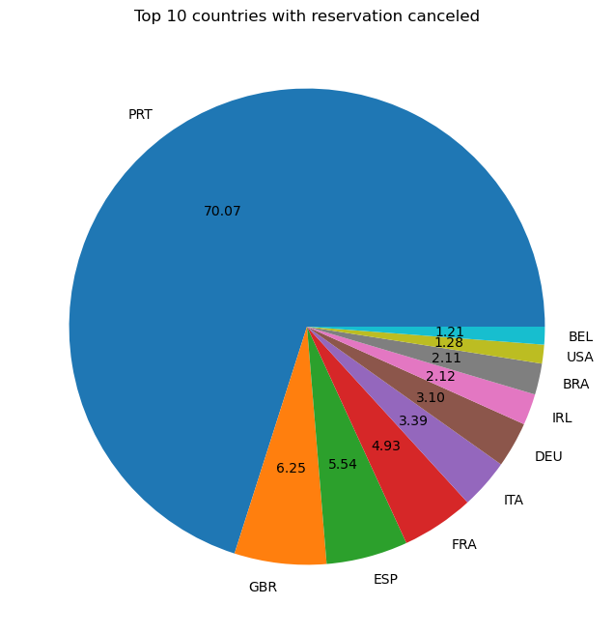

On the country basis, Portugal has the highest number of cancellation.

Let’s check the area from where guests are visiting the hotels and making reservations. Is it coming from Direct or Groups, Online or Offline Travel agents? Around 46% of the clints come from online travel agencies, where as 27% come from groups. Only 4% of clients book hotels directly by visiting them where as making reservations.

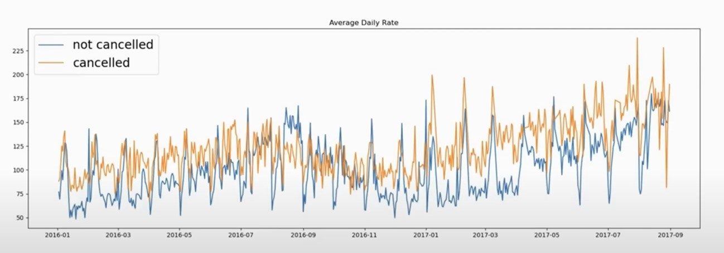

As seen in the graph, reservations are canceled when the average daily rate is higher than when it is not canceled. It clearly proves that the higher price leads to higher cancellation.

**Suggestions**

1. Cancellation rates rise as the price does. In order to prevent cancellation of reservations, hotel could work on their pricing strategies and try to lower the rates for specific hotels based on locations.

2. The ratio of the cancellation to not cancellation of the resort hotel is higher than the city hotels. So, the hotels should provide a reasonable discount on the room prices on weekends or holidays.

3. In the month of January, hotels can start campaigns or marketing with a reasonable amount to increase their revenue as the cancellation is the highest in this month.

4. They can also increase the quality of their hotels and services mainly in Portugal to reduce the cancellation rate.